The Living Jesus
Reading: from John 20:11-18
But Mary Magdalene stood outside the tomb crying. As she cried, she bent over to look into the tomb. She saw two angels dressed in white. They were seated where Jesus’ body had been.
They asked her, “Woman, why are you crying?” “They have taken my Lord away,” she said. “I don’t know where they have put him.” Then she turned round and saw Jesus standing there. But she didn’t realise that it was Jesus.
He asked her, “Woman, why are you crying? Who are you looking for?” She thought he was the gardener. So she said, “Sir, did you carry him away? Tell me where you put him. Then I will go and get him.”
Jesus said to her “Mary.” She turned towards him. Then she cried out in the Aramaic language, “Rabboni!” which means Teacher.
Jesus said, “Do not hold onto me. I have not yet ascended to the Father. Instead, go to those who believe in me.”
Mary Magdalene went to the disciples with the news. She said, “I have seen the Lord!”

Thought about the reading
Today’s story takes place early in the morning on the first Easter Sunday. Two days before, on Good Friday, Jesus’ friends had seen him die when he was nailed on a cross. They had seen his body put into a tomb which was like a cave and a big stone rolled over the entrance. They were all very sad. They thought that was the end.
But it was not the end! God the Father raised Jesus back to life on the Sunday. Mary Magdalene was the first person to see him. Later, he appeared to all his friends. It was hard to believe at first that someone who had died could come back to life, but it was true. They were very happy.
Even more wonderful, Jesus will never die again. He lives for ever with the Father in heaven. He promised that if we follow him, he will always be with us. When we die, we too will live forever in heaven with him.

Prayer
Dear Jesus, we praise you that although you died for us on the cross, death was not the end for you. You came back to life, so that you could give us new life.
Christ has died, Christ has risen, Allelujah! Amen

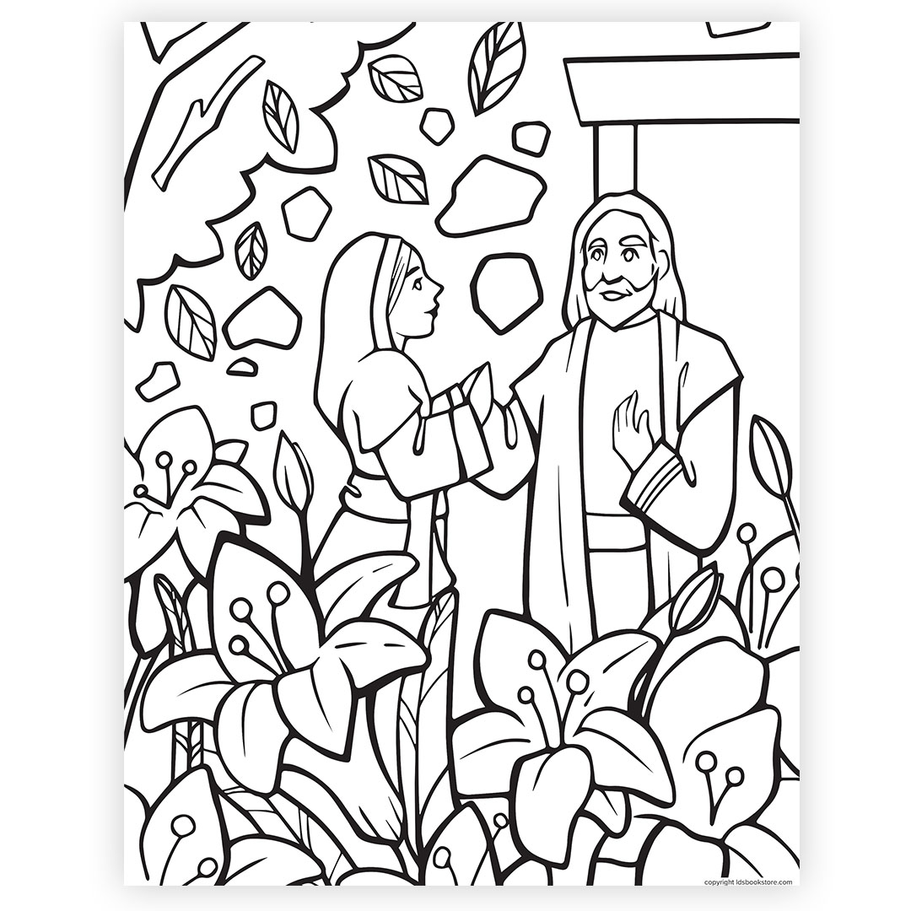

Cambridge Causeway

Autumn 2025
Bible Study notes

Jesus the Reason
5. The Living Jesus
By Chrissy Cole

